Slam_bot and path following algorithm package(follow_waypoints) simulation running steps

Pay attention to：

Please refer to the “**Path executor description document.doc”** file to set the “**follow_waypoints** ”package before using it

1. Copy the **slam_bot** and **follow_waypoint** packages to the SRC folder under the corresponding project workspace folder under ROS, and run catkin_make in the WS folder to compile and generate the executable file.
2. Source ./devel/setup.bash
3. roslaunch slam_bot demo_slam_gd_amcl_fusion.launch

The system will open the RVIZ window to display the robot perspective interface, and open the Gazebo simulation window to import the 3D simulation model. Rviz shows a one-to-one mapping relationship between the robot and Gazebo simulation model, and RVIZ displays the robot sensor perspective.

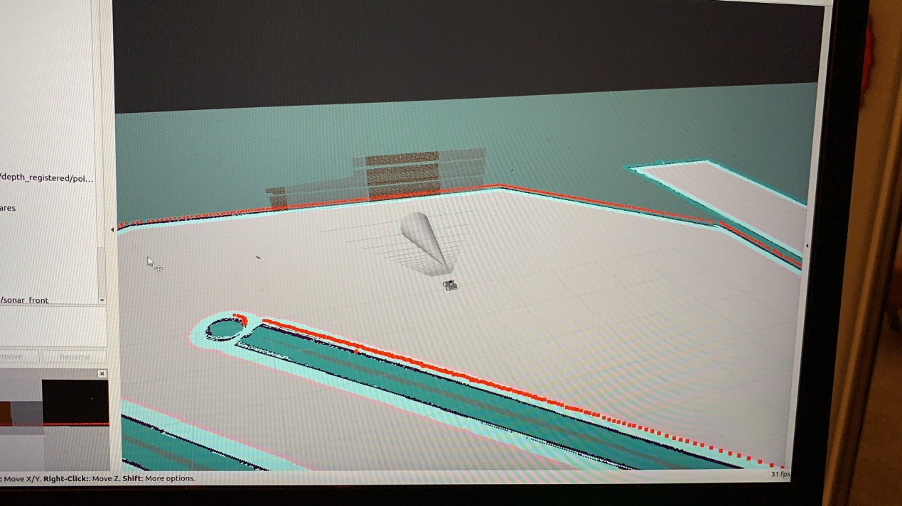

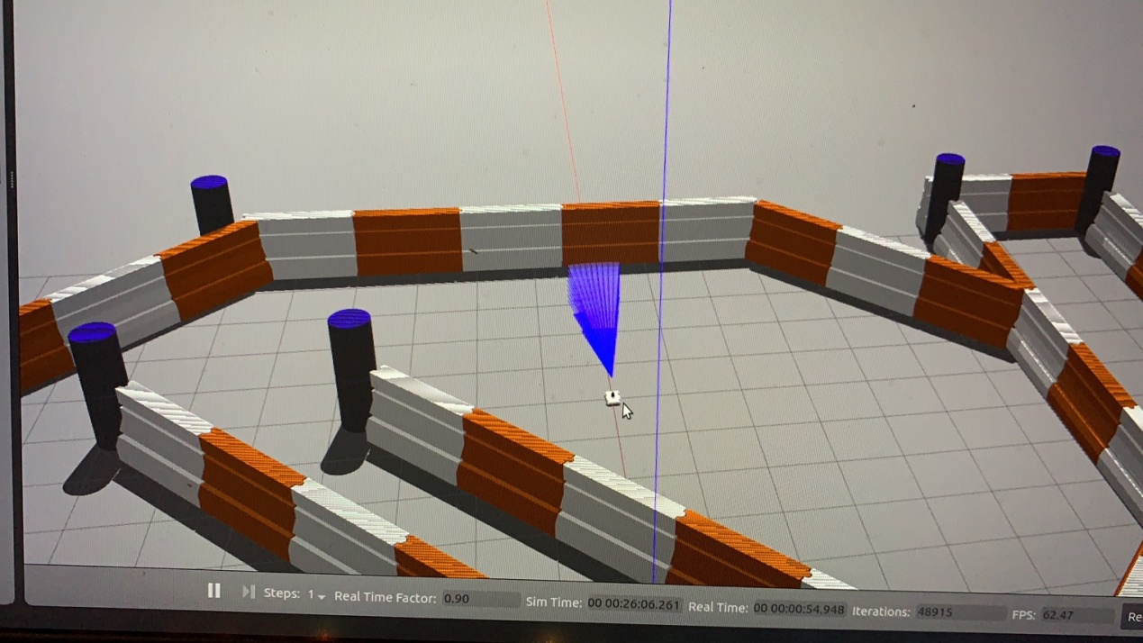

1. Open up another terminal：Source ./devel/setup.bash
2. roslaunch follow_waypoints follow_waypoints.launch

If the command is successfully executed, the following information is displayed on the terminal

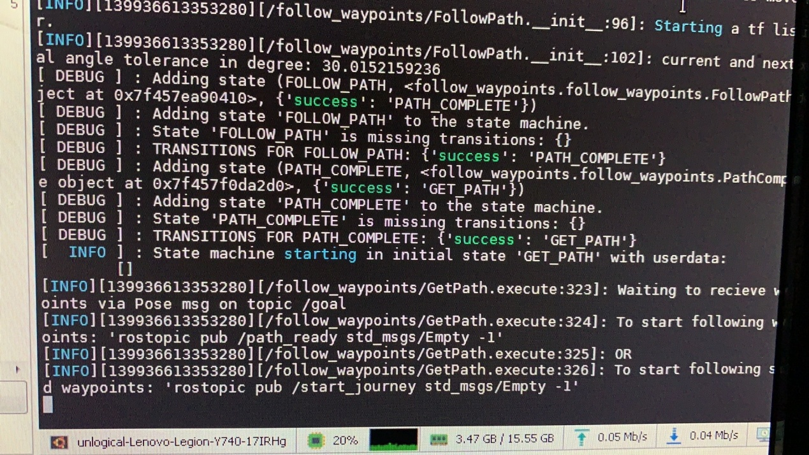

7. Open another terminal and enter：

rostopic pub /start_journey std_msgs/Empty -1

The system will import the navigation path corresponding to the map (red arrow), as shown in the figure below, and the robot will traverse and execute the path in turn

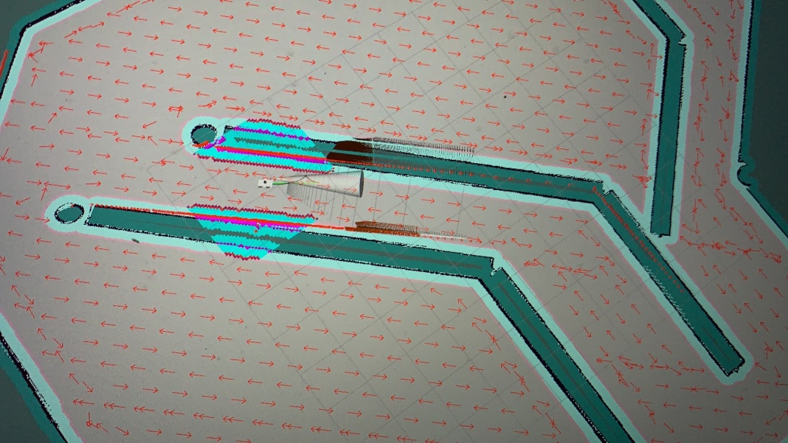

Path File Description

The **Follow waypoints** package will control the navigation path in the move Base navigation package execution file. The navigation path file is the pose file in the corresponding **saved_path** folder. It should be noted that the pose file used should be corresponding to the relevant map

